Cell-Free Massive MIMO with MMSE Processing: Simulation Report
Reproduction of figures from: Bjornson & Sanguinetti, "Making Cell-Free Massive MIMO Competitive With MMSE Processing and Centralized Implementation," IEEE TWC, vol. 19, no. 2, Feb. 2020.

Figure 2(a): CDF of Per-User SE, MMSE/L-MMSE Combining (L = 400, N = 1, K = 40)
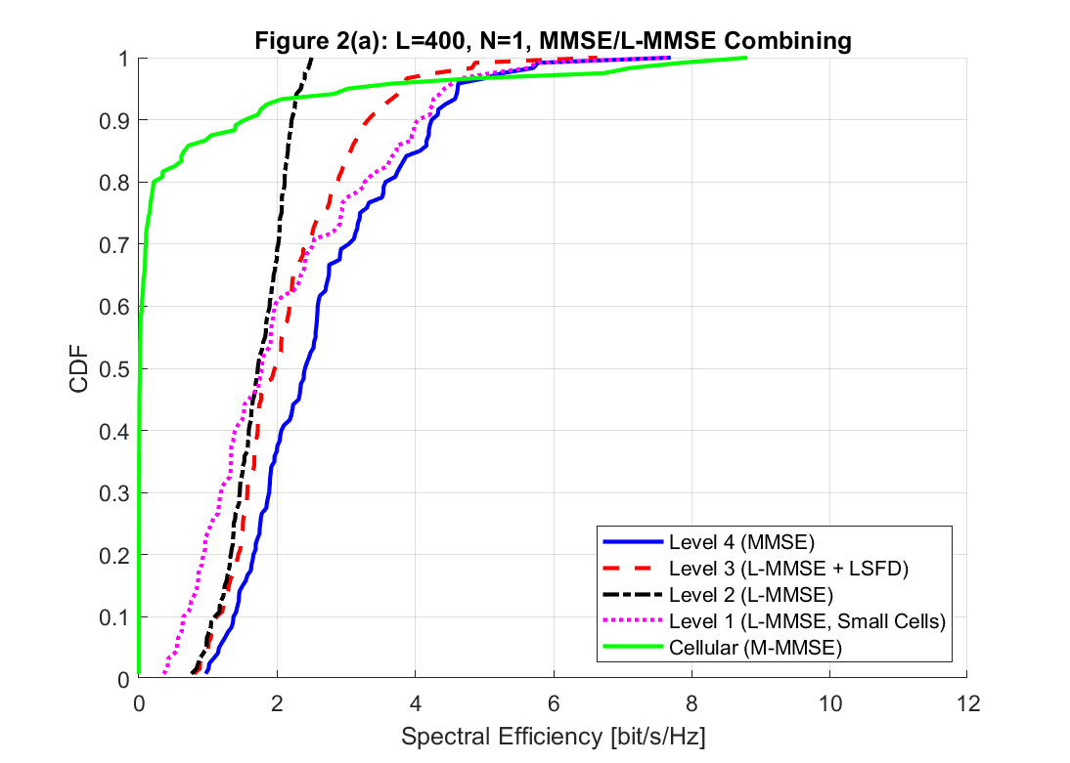
This figure shows the CDF of per-user uplink spectral efficiency for all four cooperation levels of Cell-Free Massive MIMO using MMSE / L-MMSE combining, benchmarked against cellular Massive MIMO with M-MMSE. Level 4 (fully centralized MMSE) provides the best performance across the whole CDF because the CPU has access to all local channel estimates and can suppress inter-user interference jointly. Level 3 (L-MMSE + LSFD) is close but slightly worse due to distributed combining, while Level 2 (uniform weighted L-MMSE) and Level 1 (small cells) trail further behind. The key insight is that with MMSE processing, centralized Cell-Free MIMO clearly outperforms cellular Massive MIMO, particularly for the weaker 5%-outage users.

Figure 2(b): CDF of Per-User SE, MMSE/L-MMSE Combining (L = 100, N = 4, K = 40)
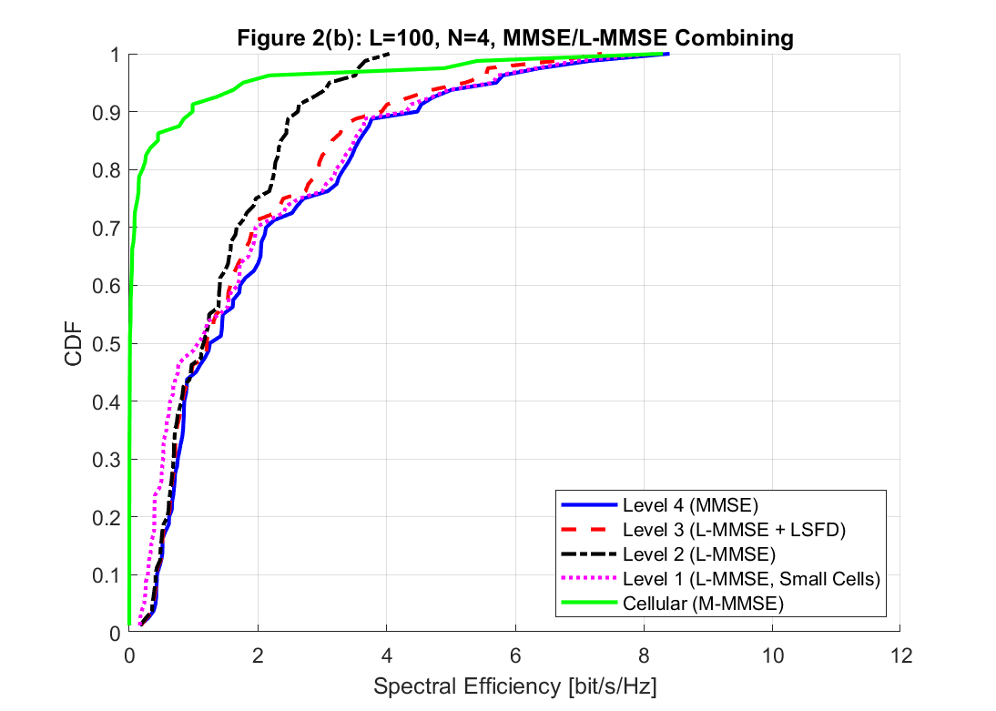
Here the same comparison is done with fewer APs (L = 100) but each equipped with N = 4 antennas, keeping the total number of antennas at LN = 400. Multi-antenna APs significantly improve Level 1 (small cells) thanks to local spatial filtering, and also narrow the gap between Levels 2/3 and Level 4. This configuration is important because it is more practical to deploy 100 4-antenna APs than 400 single-antenna APs. Cell-Free with MMSE still beats cellular for median and cell-edge users.

Figure 3: CDF of Per-User SE, MR Combining (L = 400, N = 1, K = 40)
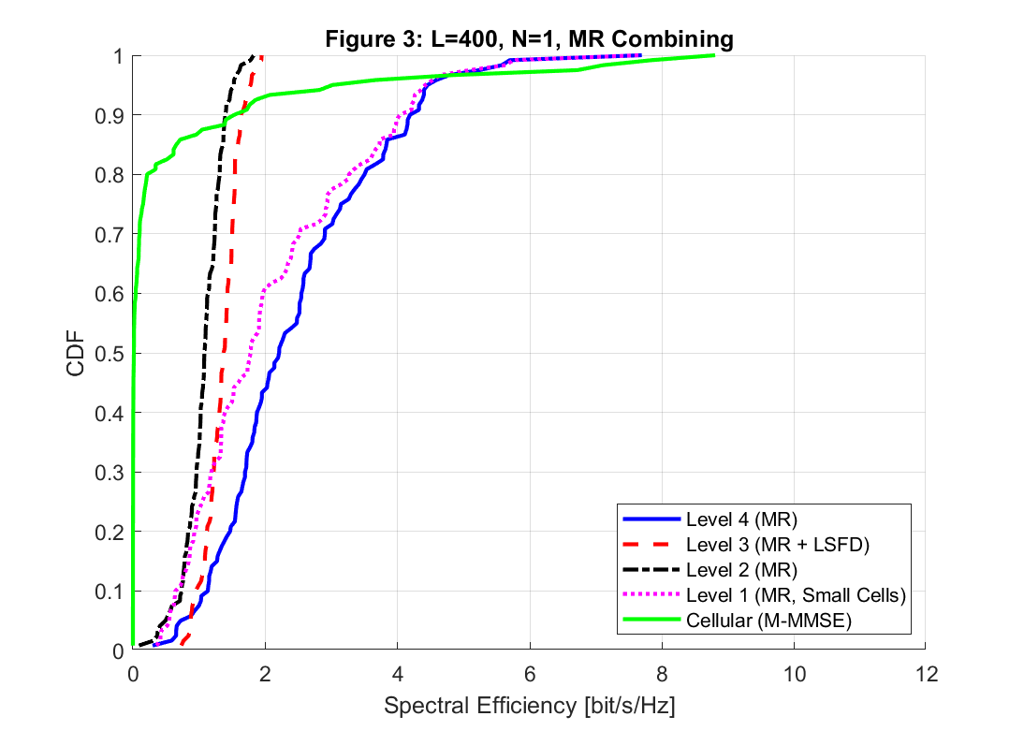
This figure uses the same network as Figure 2(a) but replaces MMSE combining with plain Maximum-Ratio (MR) combining. The result is the opposite conclusion: every level of Cell-Free MIMO with MR is clearly worse than cellular Massive MIMO with M-MMSE. MR cannot suppress inter-user interference, so pilot contamination and residual interference dominate. This is the central point of the paper: the choice of combining scheme decides whether Cell-Free is actually competitive. MR, which was used in many early Cell-Free papers, makes Cell-Free look inferior.

Figure 4(a): Revisiting Ngo et al. Three-Slope Model, Full-Power (L = 100, N = 1)
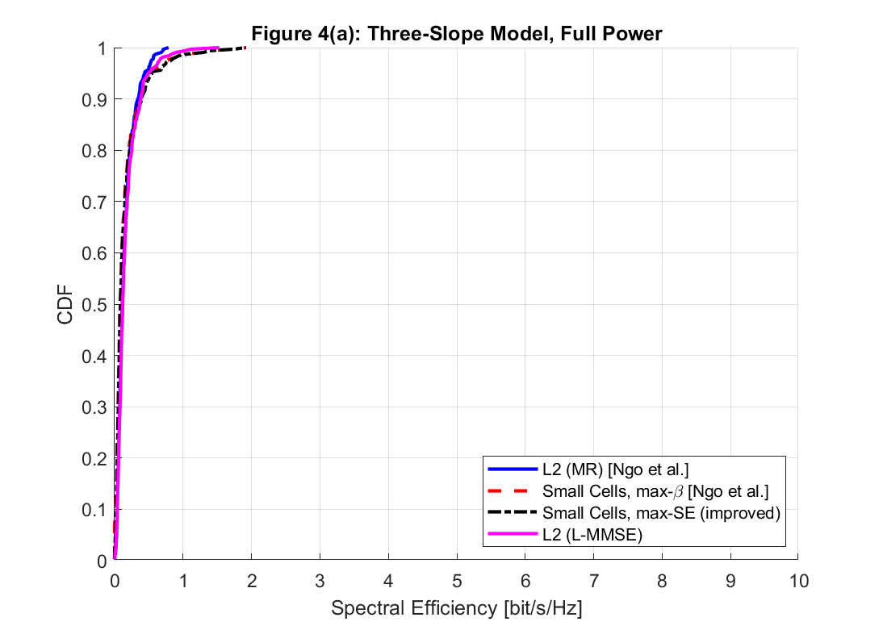
Using Ngo et al.'s three-slope propagation setup, this figure compares Level 2 MR (Ngo's original), small cells with max-beta selection (Ngo's original), small cells with max-SE selection (improved), and Level 2 with L-MMSE. The improved max-SE AP selection clearly beats max-beta, and Level 2 with L-MMSE dominates everything. This means the original Cell-Free vs Small-Cells comparison in the literature was misleading: using correct SE expressions and better AP selection already shrinks the advantage of Cell-Free, and using L-MMSE combining is essential to make it truly competitive.

Figure 4(b): Three-Slope Model, Max-Min Fairness Power Control
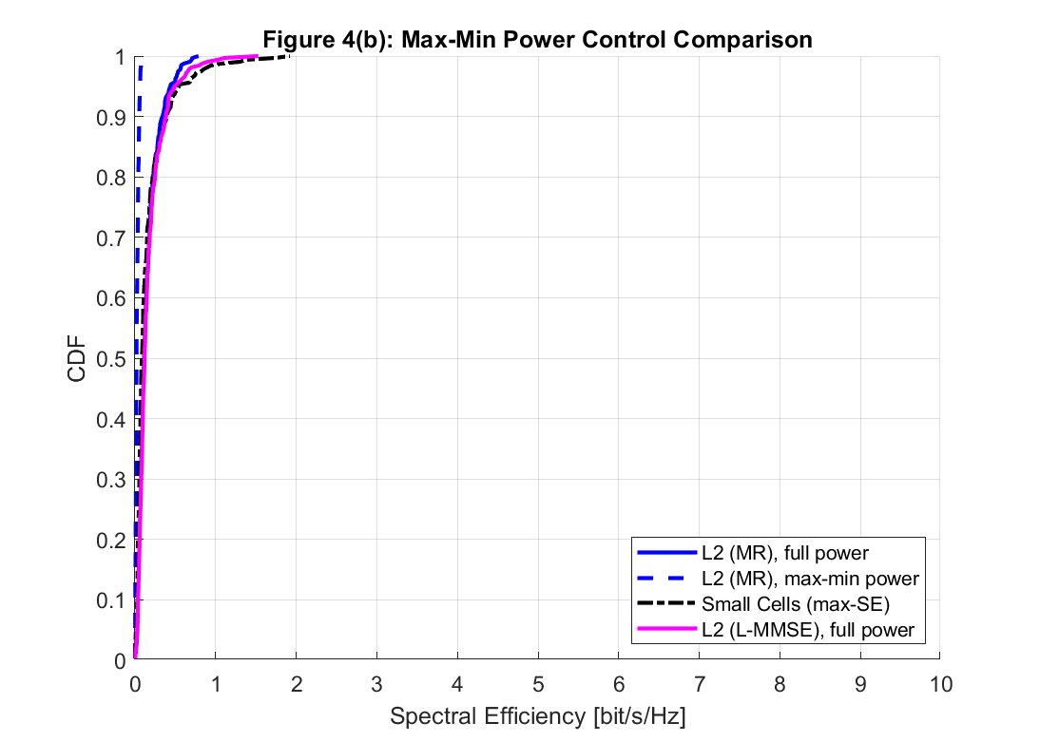
This figure shows what happens when max-min fairness power control is added to Level 2 MR in the three-slope model. Max-min power control lifts the cell-edge (5%-outage) SE, but at the cost of reducing the upper-percentile SE. Level 2 with L-MMSE at full power still outperforms Level 2 MR with max-min power over most of the CDF. The takeaway: improving the combining scheme (MR to L-MMSE) delivers larger gains than complex per-user power control on top of MR.

Figure 5: Sum Spectral Efficiency, MMSE-SIC vs Linear Combining (L = 400, N = 1)
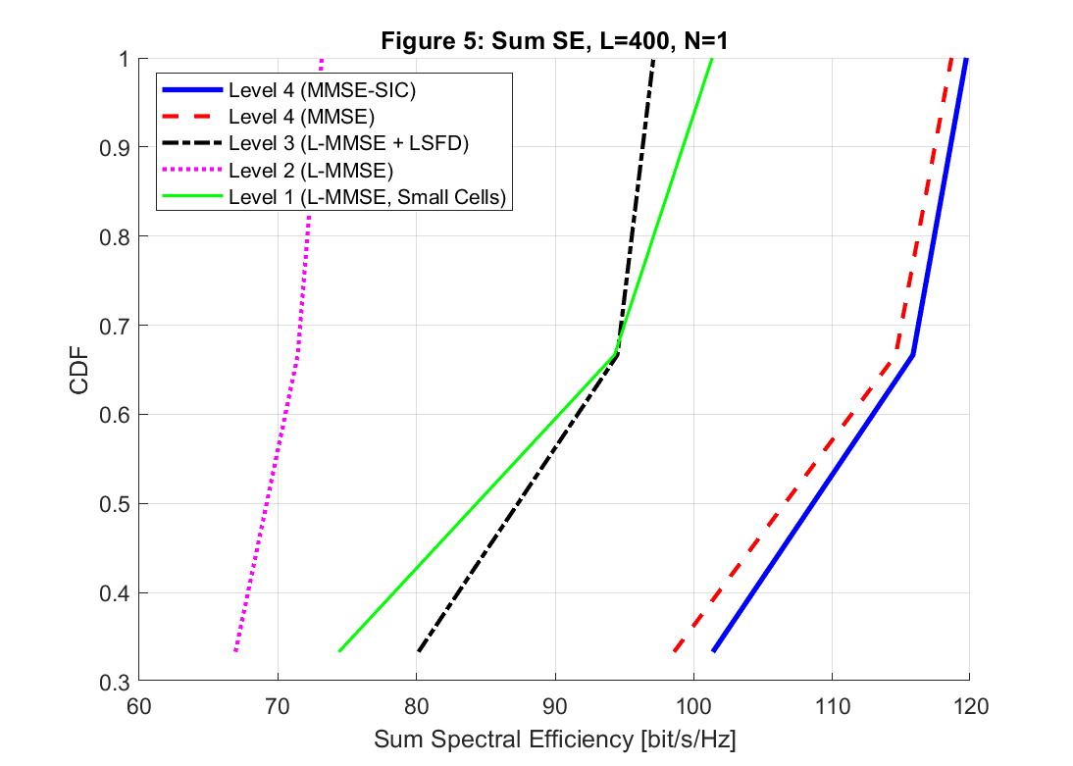
This figure compares the sum SE achievable with Level 4 MMSE-SIC (successive interference cancellation, Proposition 4) against all linear combining schemes. The gain of MMSE-SIC over linear MMSE is extremely small (on the order of 1%), which is a consequence of the favorable propagation regime where L >> K. In practice, linear MMSE combining captures almost all the achievable capacity. This is good news for implementation: linear receivers are much easier to realize than SIC receivers, and the performance loss is negligible.

Figure 6: Fronthaul Signaling Load vs Coherence Block Length tau_c (L = 100, N = 4, K = 40)
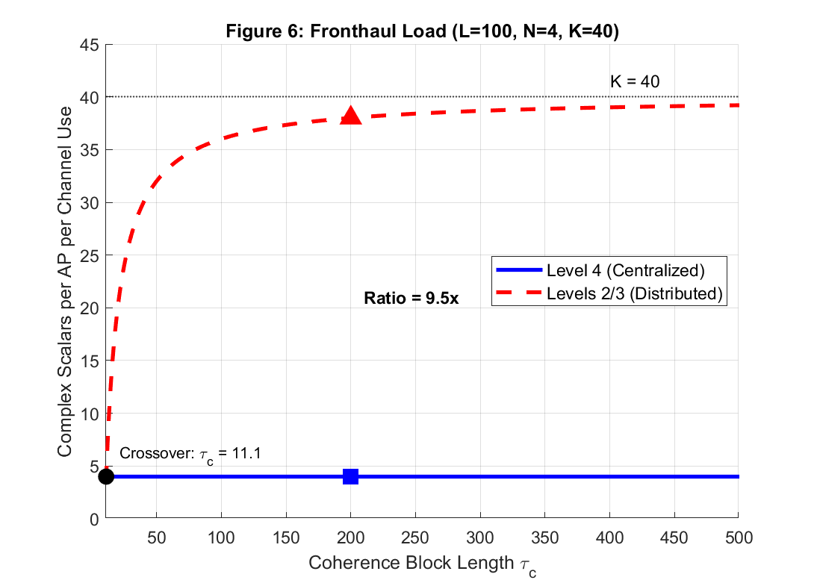
This is a purely analytical plot comparing the fronthaul load (complex scalars per AP per channel use) between centralized Level 4 and distributed Levels 2/3. Level 4 sends N scalars per channel use (independent of tau_c), while Levels 2/3 send (1 - tau_p/tau_c)*K scalars per channel use, which saturates to K. The crossover occurs at a very small tau_c (~11), so for any realistic coherence block length Level 4 actually requires LESS fronthaul signaling than Levels 2/3. This upends the common assumption that distributed processing must be more fronthaul-efficient: when K > N, centralized processing is both more spectrally efficient and more fronthaul-efficient.

